Lab 8: Super/Subtype, Step Dimension, Dashboard II

Name: Amisha Farhana Shaik

I couldn’t open the tableau file for this, however I did use the lab recording for understanding this topic and completing the Assignment 3.

3. Create Advanced Filter:
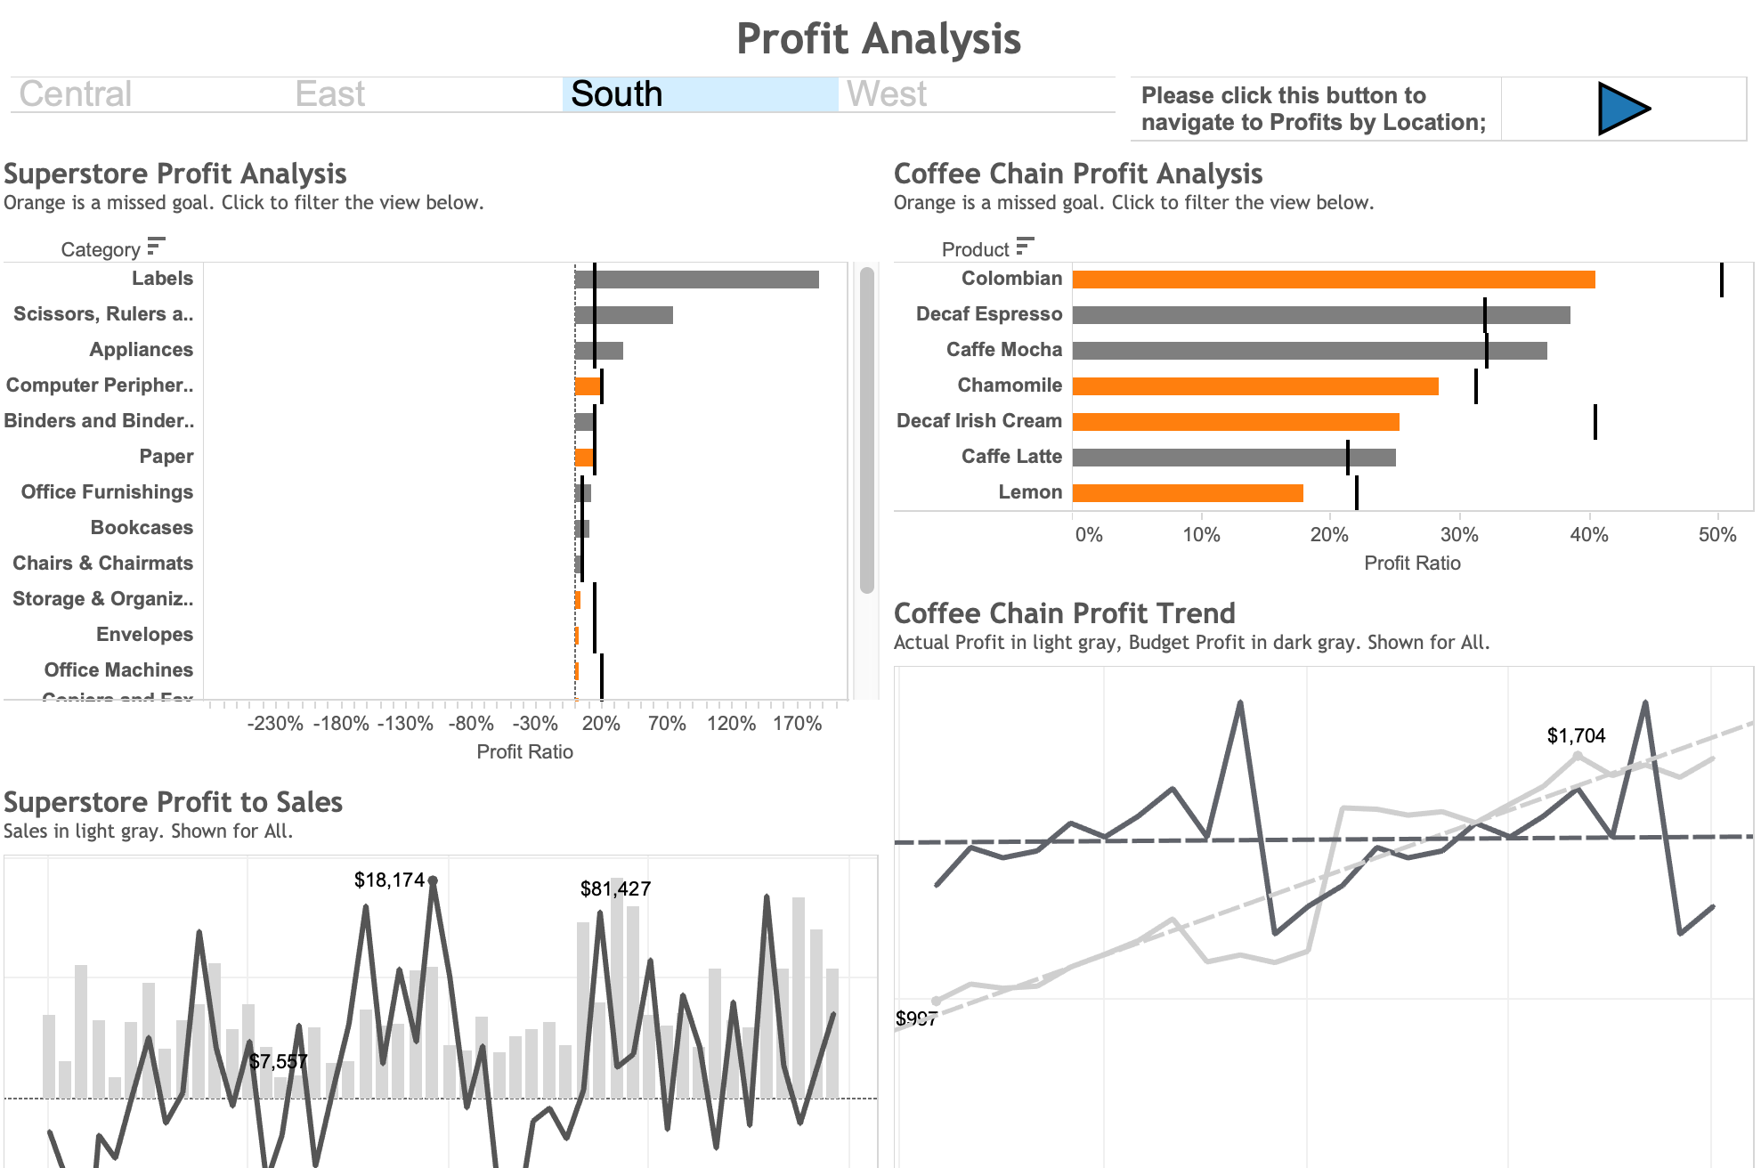
a. Create a region selection view for filter;
b. Use the region selection as the filter to add a filter action, that allows it not only filter superstore, but also coffee shop analysis;
c. Create button navigation views for future linking to Profits by Location, and linking back to Profit Analysis;
d. Use the button navigation as the filter to add a filter action, that allows to navigate to other dashboards;

4. Adding Context to Dashboard Filter Actions
For the main markets that use Superstore, you want to help users see only the top 25 cities and the top 10 products for sales. Use Top N filters to limit the view results. Then, use dashboard filter actions to filter all views by Market and the top product names by city.
a. On the top 10 Product Sales worksheet, add a filter for the top 10 Product Names by Sales;
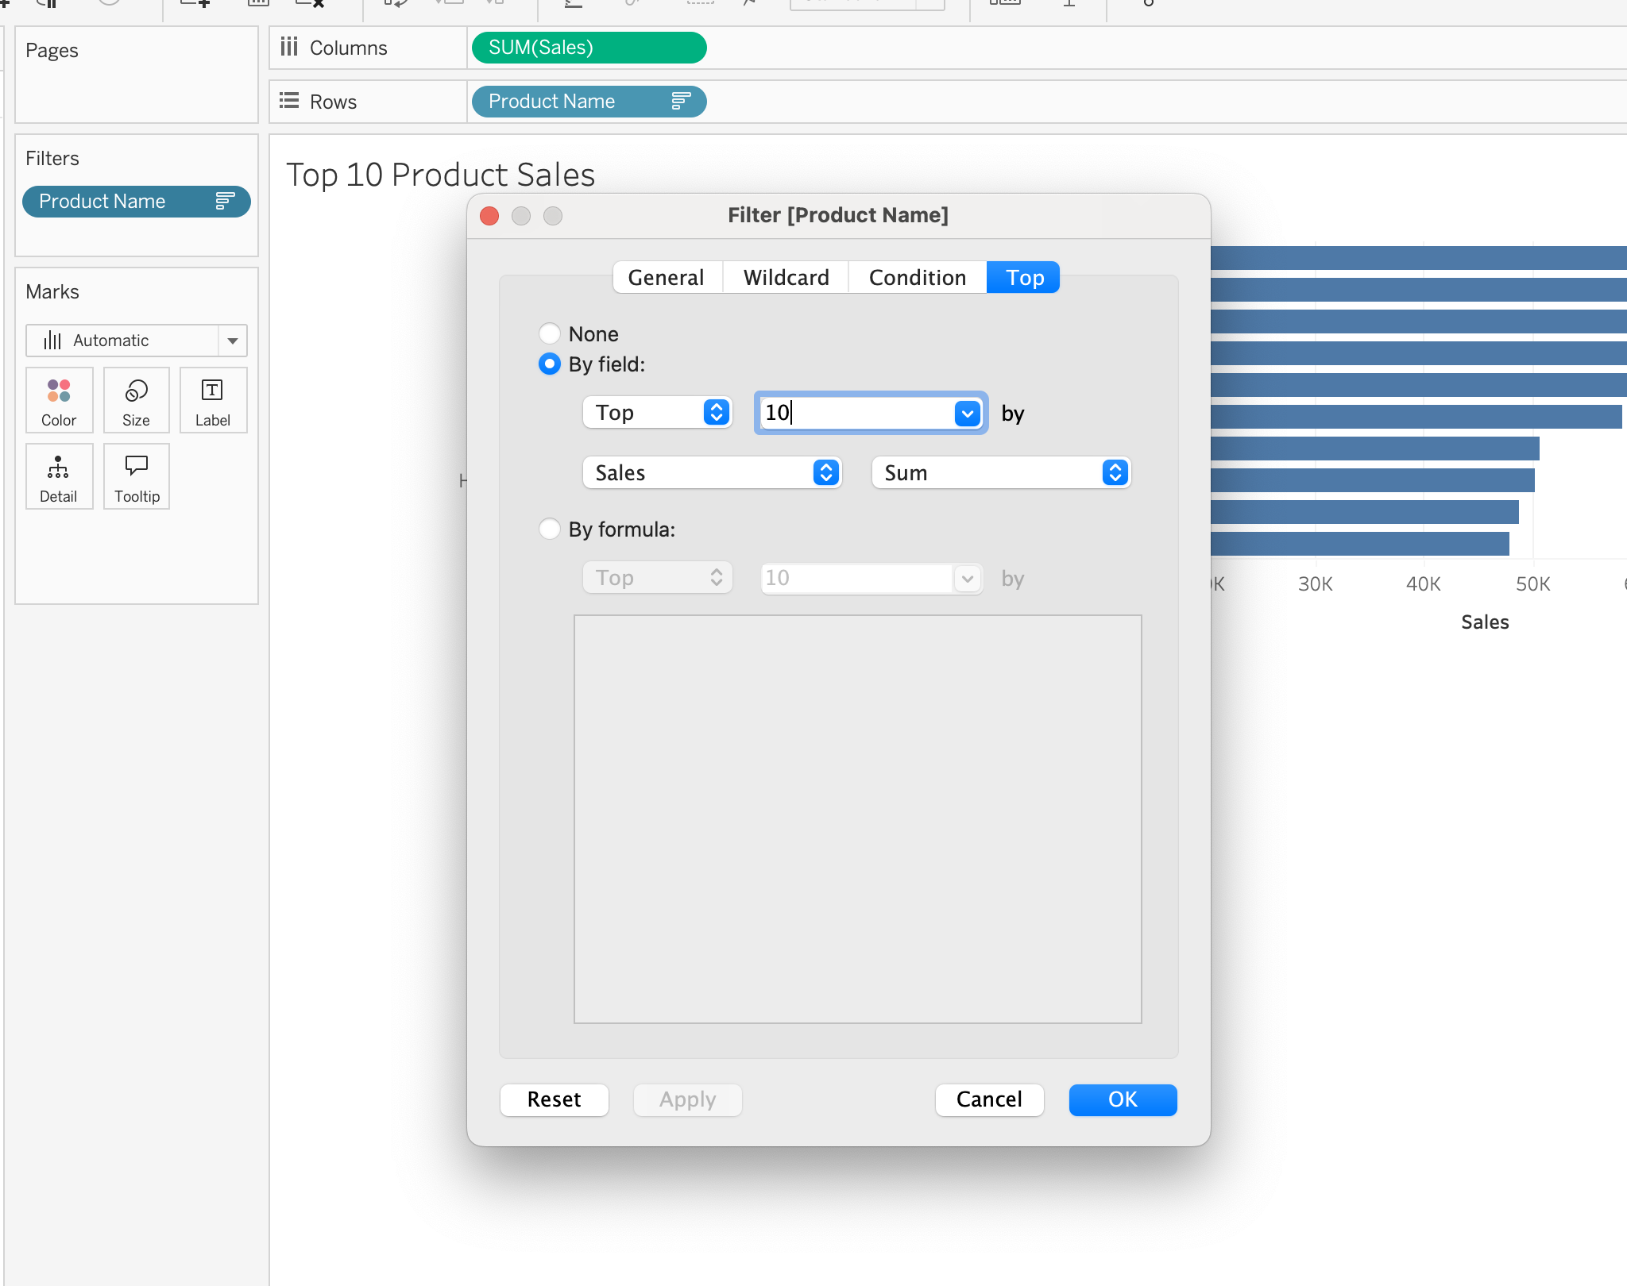

b. On the top 25 Cities for Sales worksheet, add a filter for the City and State field for top 25 by Sales.
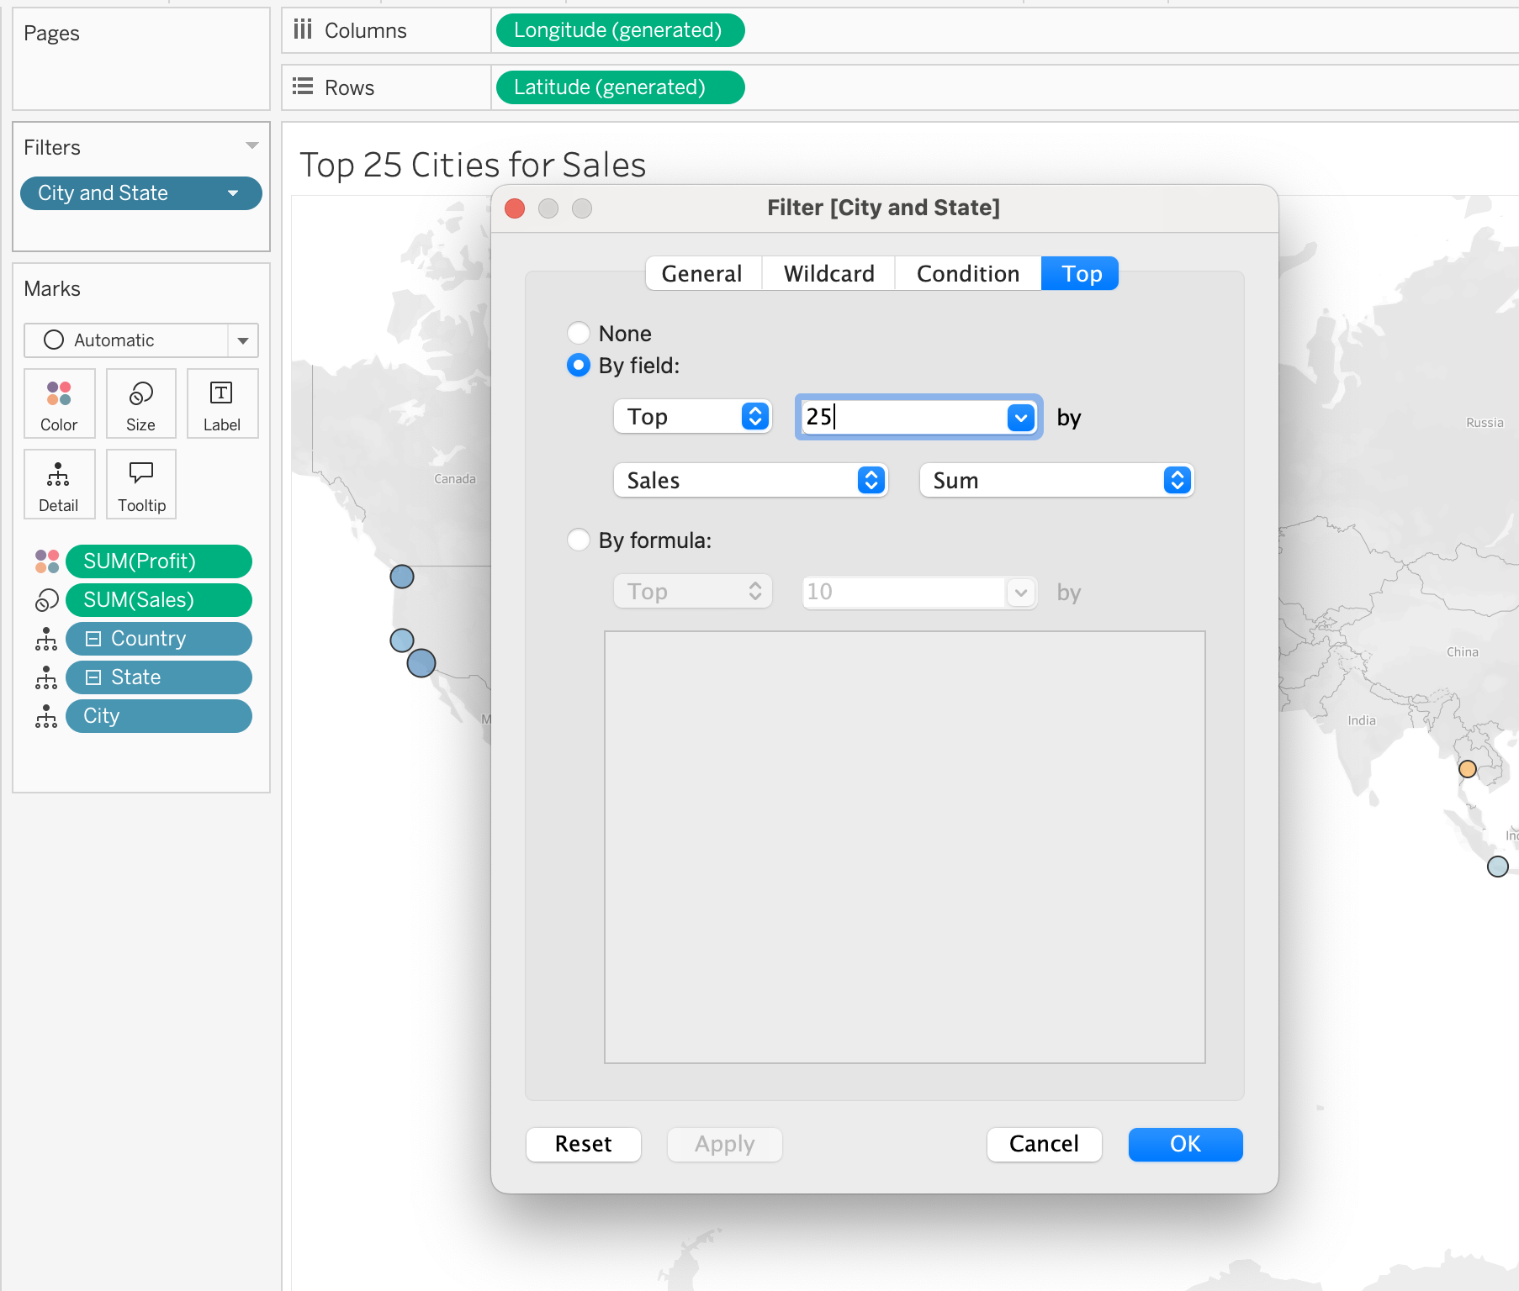
c. On the Worldwide Sales dashboard, use the Market sheet as a filter, then test it to observe the results.
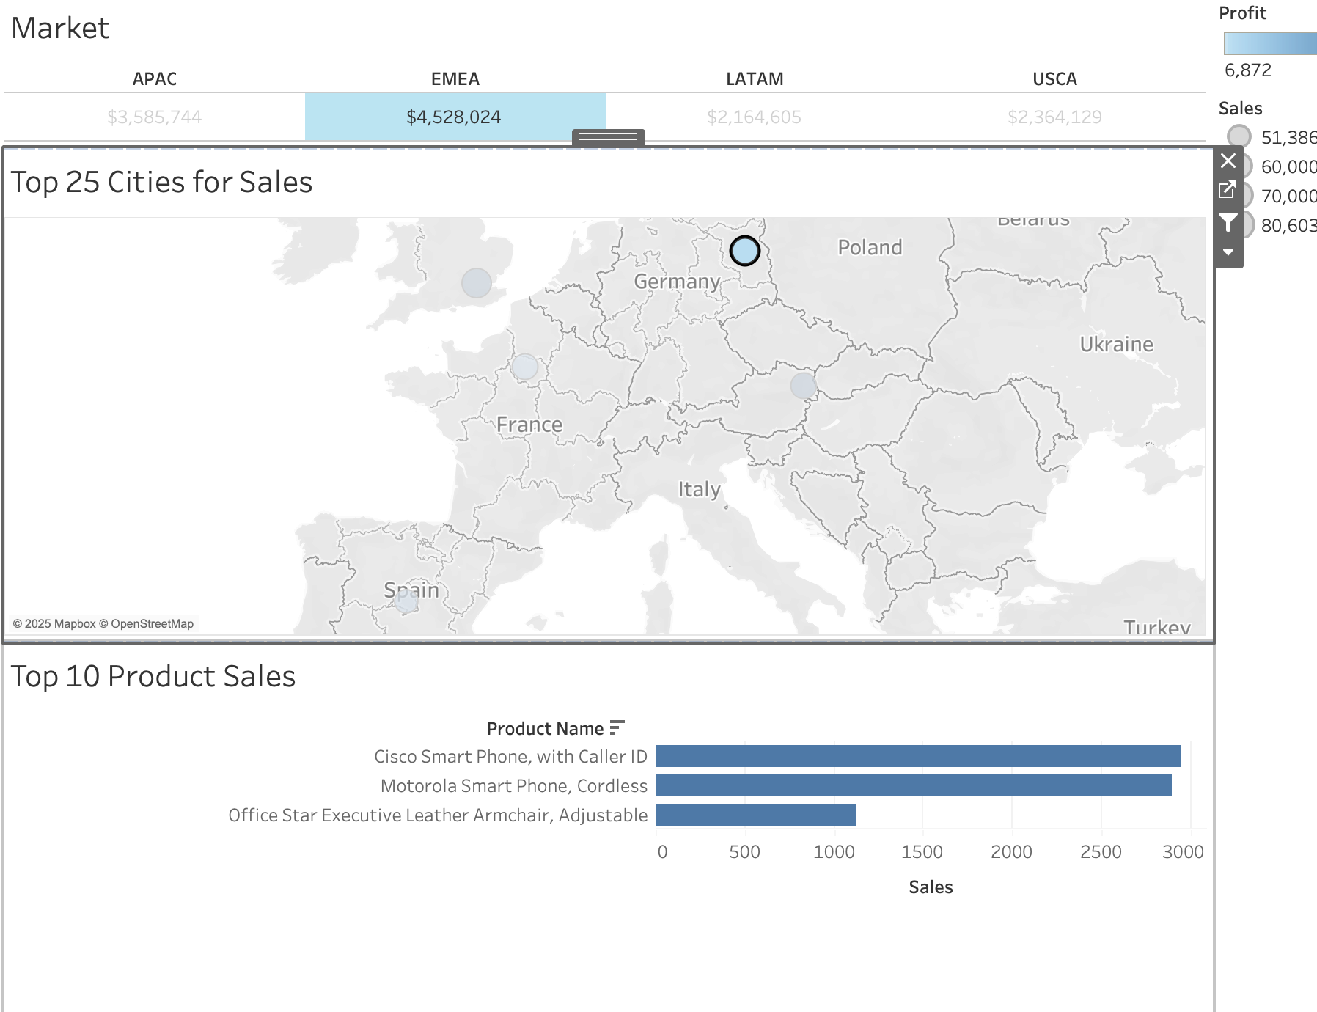

d. Generate a filter using Market as the source, and top 25 cities for sales as the target; Use city as the context to the filter.
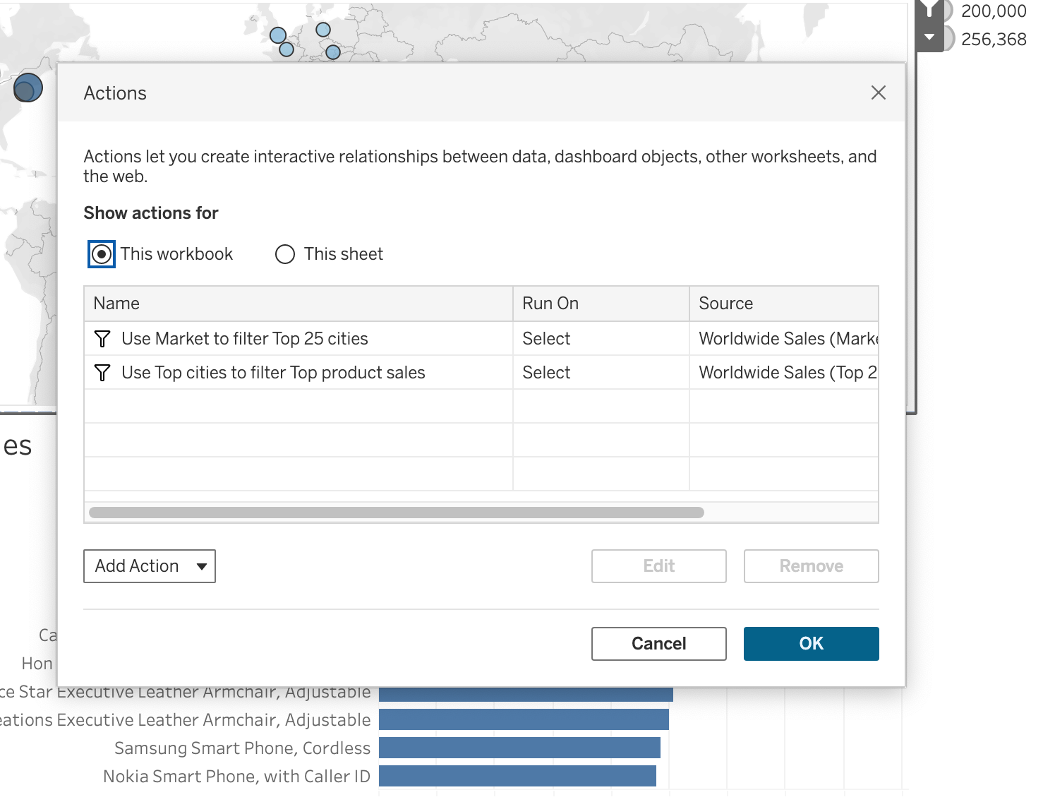
e. Generate a filter using Top 25 cities for sales as the source, and top 10 product for sales as the target; Use product name as the context to the filter.
